Snowflake

Assignment – I

By

Mouli S

Batch - 02

[moulisankar2002@outlook.com](mailto:moulisankar2002@outlook.com)

**Question:**

Load CSV files from S3 bucket into Snowflake. Please create table structure as per the csv file format.

Following is the link to S3 bucket:

1.     <https://s3.ap-southeast-2.amazonaws.com/snowflake-essentials/customer.csv>

2.     <https://s3.ap-southeast-2.amazonaws.com/snowflake-essentials/external_table/credit_cards.csv>

For loading “<https://s3.ap-southeast-2.amazonaws.com/snowflake-essentials/customer.csv>”

**Code:**

CREATE TABLE customer_details

(

ID VARCHAR(200),

Name VARCHAR(200),

Address VARCHAR(200),

City VARCHAR(200),

PostCode INT,

State VARCHAR(200),

Company VARCHAR(200),

Contact VARCHAR(200)

);

CREATE STAGE my_s3_stage_cust url='s3://snowflake-essentials/'

copy into DB_LEARN_FROM_VINIT_02.STAGING.CUSTOMER_DETAILS

from s3://snowflake-essentials/customer.csv

file_format = (type = csv field_delimiter = '|' skip_header = 1)

SELECT * FROM customer_details;

**Result:**

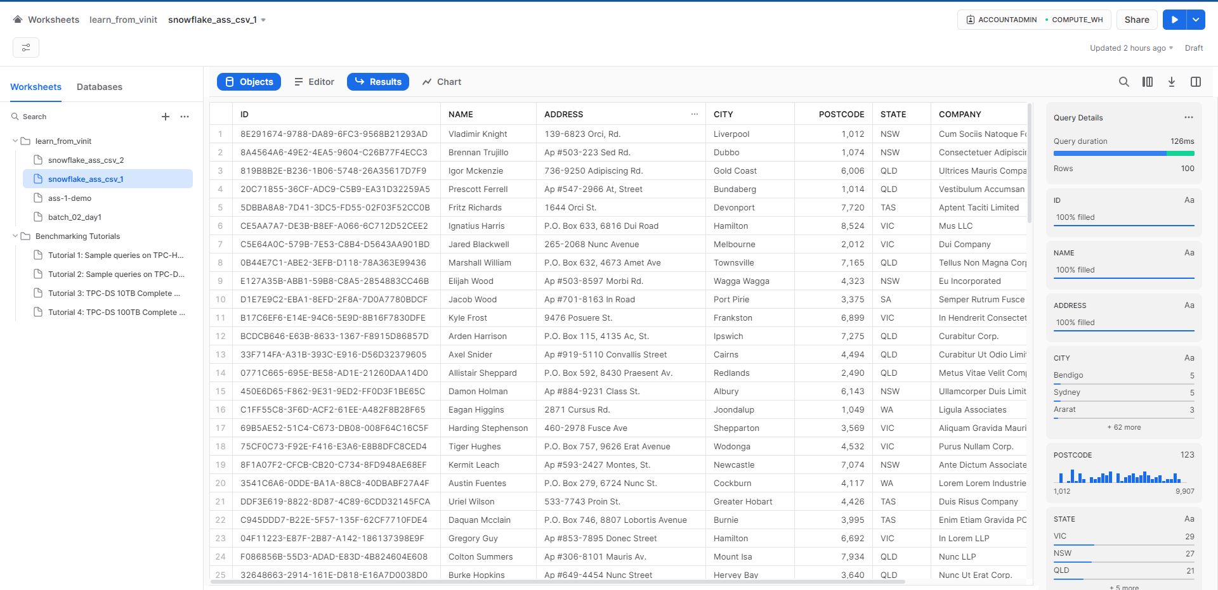

For loading “https://s3.ap-southeast-2.amazonaws.com/snowflake-essentials/external_table/credit_cards.csv”

**Code:**

CREATE TABLE SNOWFLAKE_02_CC(

Customer_ID|Customer_Name|Customer_Email|Customer_City|Customer_State|Customer_DOB

)

CREATE STAGE my_s3_stage_cc url='s3://snowflake-essentials/external_table'

COPY INTO DB_LEARN_FROM_VINIT_02.STAGING.SNOWFLAKE_02_CC

FROM s3://snowflake-essentials/external_table/credit_cards.csv

file_format = (type = csv field_delimiter = '|' skip_header = 1)

ON_ERROR=CONTINUE;

SELECT * FROM SNOWFLAKE_02_CC;

**Result:**

